Project Part 3

Name: Venkata Sairam Singothu

In this project part I have complete all the api integrating with mongodb and React JS. Below are the pages that I have worked on.

Summary:

Here the user can logged in as user or admin. As before logging in the user may browse the products from the inventoey but not be able to add to cart and hence the app redirects the user to login page to login. So now the user can add the product to cart and can add to checkout there he can add address and the payment information. That’s it now the user can place the order and he can the order details in myorders page. In my profile page there are some options like add products and browse products list which is not accessable to the user but can admin so user can add products and as well brows the product in a table here, he can update or delete the product.

Fallowing the screen shot of the ui I have added mongo collection screenshots.

Tech stack:

Used React JS for UI Front End: I have used most of the Hooks Like useState, useContext, useEffect, useNavigate, Functional based components.

Used dependencies like axios for HTTP requests, material ui for styling

Used Express Js for Backend: created multiple apis used mongo db for database.

Dependencies used in backend: mongo,express, cors etc…

I have learned most of the usecase of Hooks, state management in react, HTTp calls, creation of api’s and more.

Contribution: Wroked on backend frontend alone

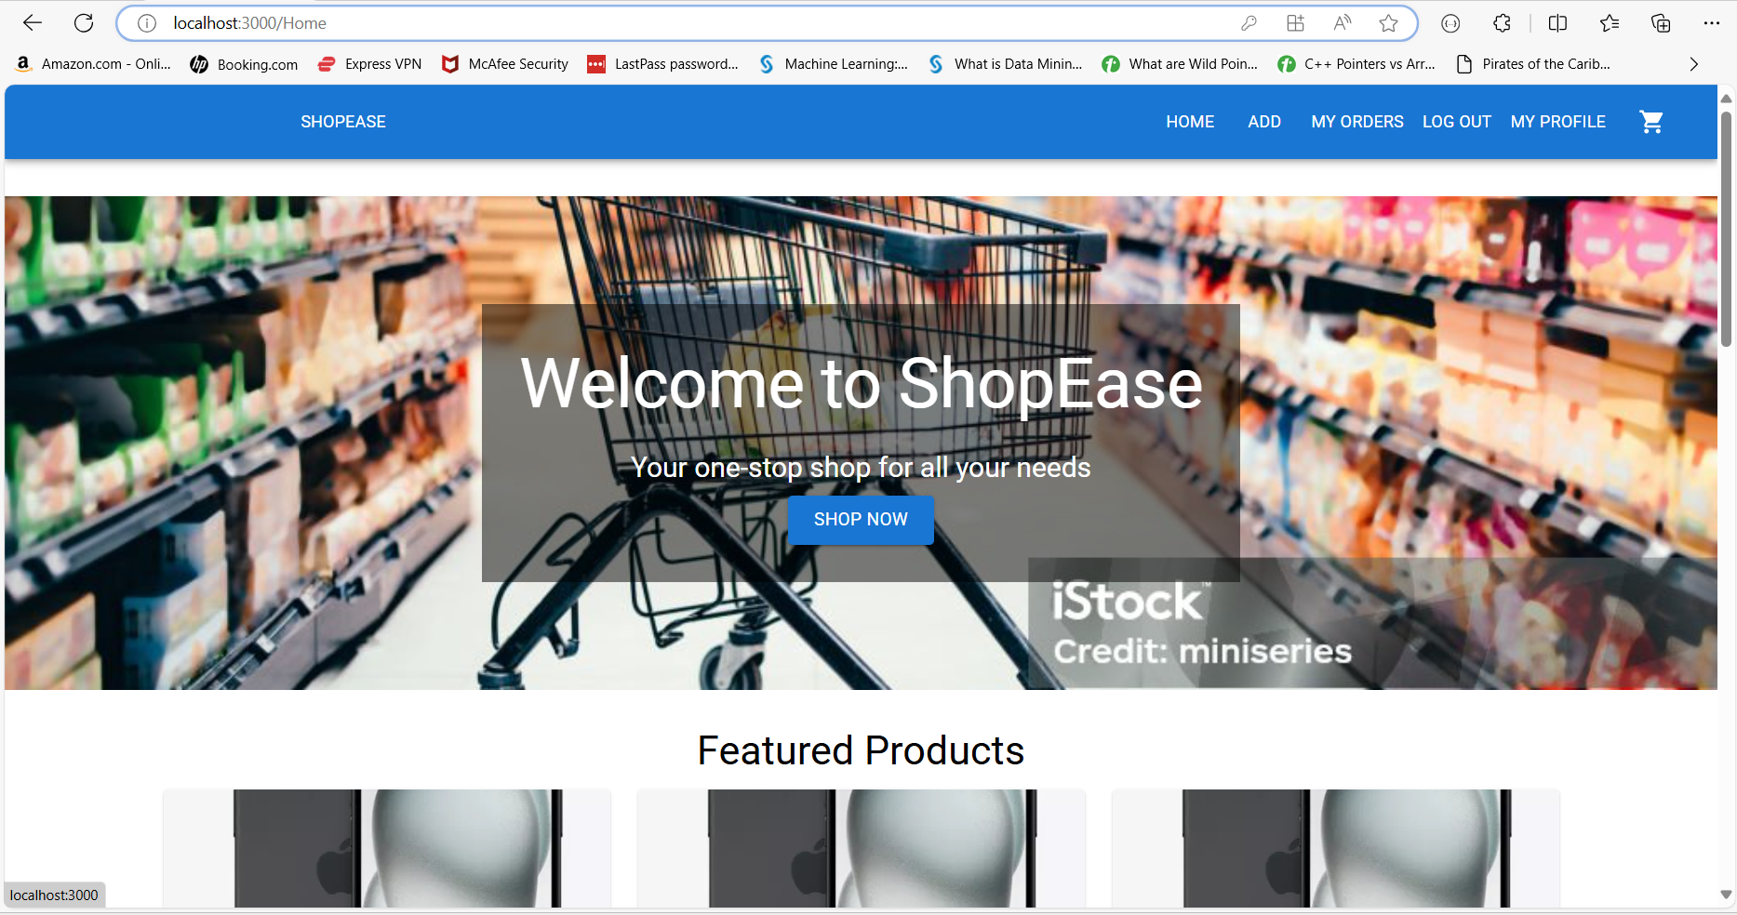

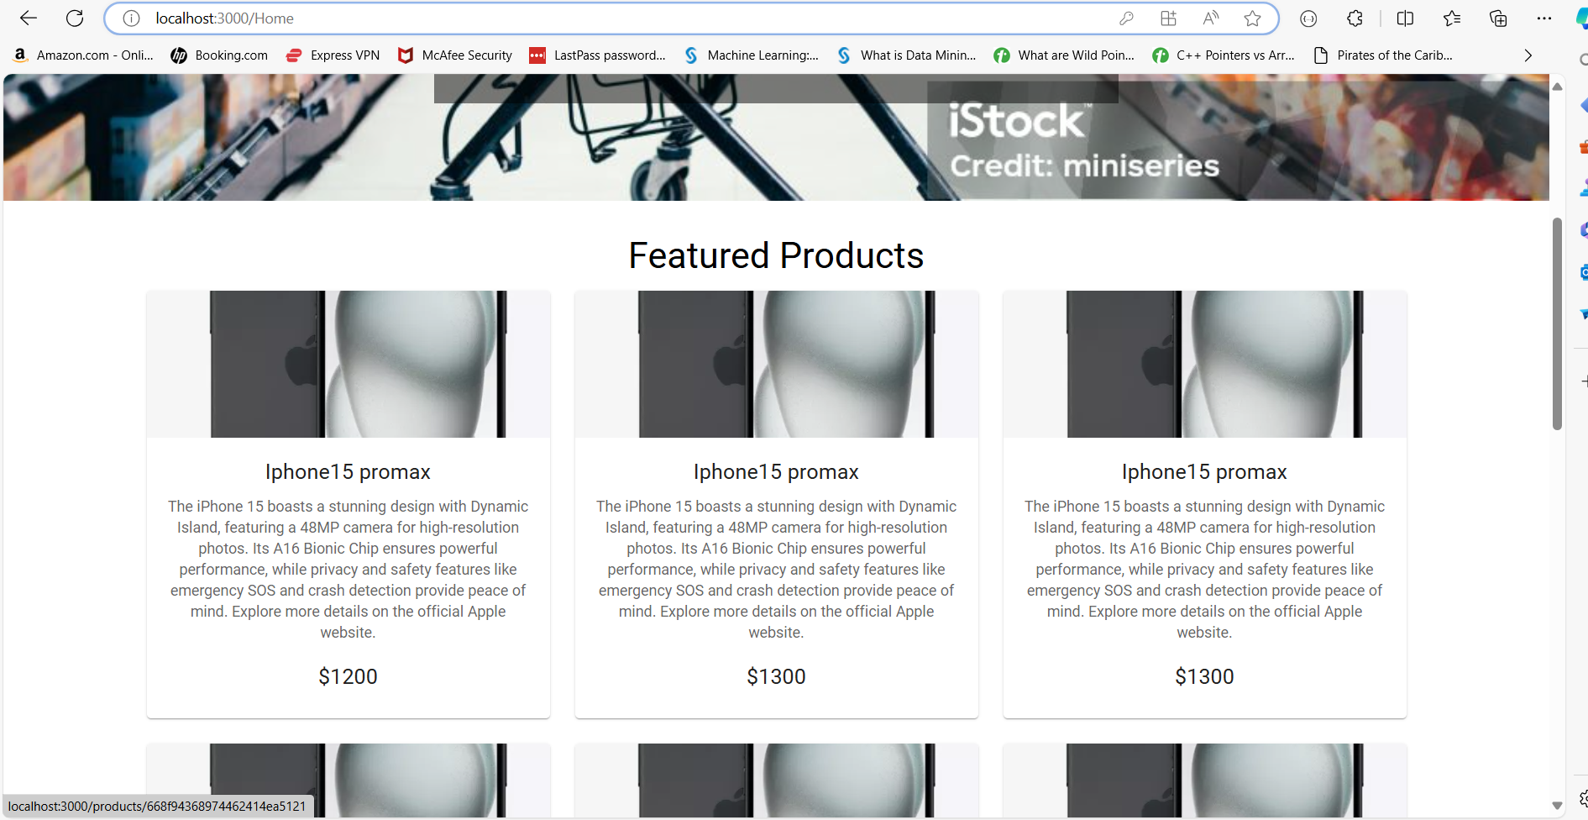

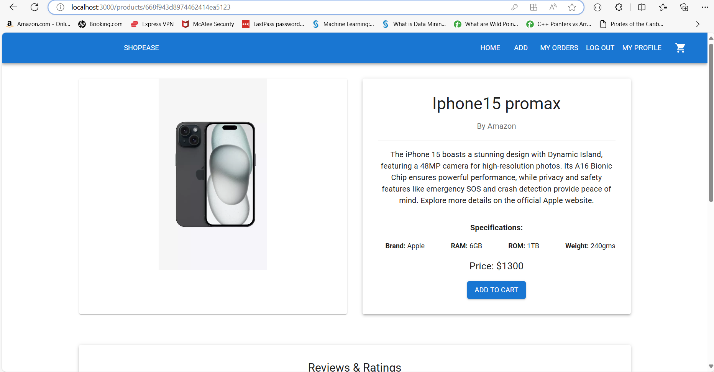

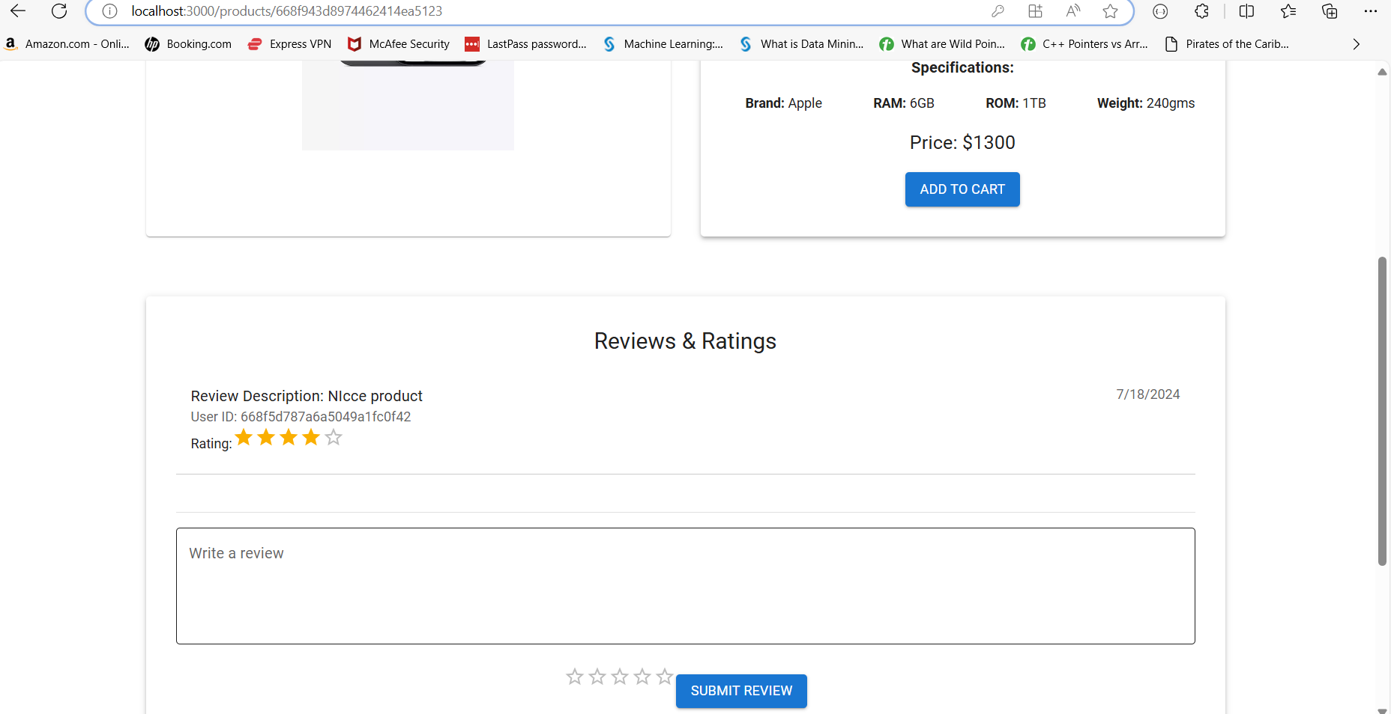



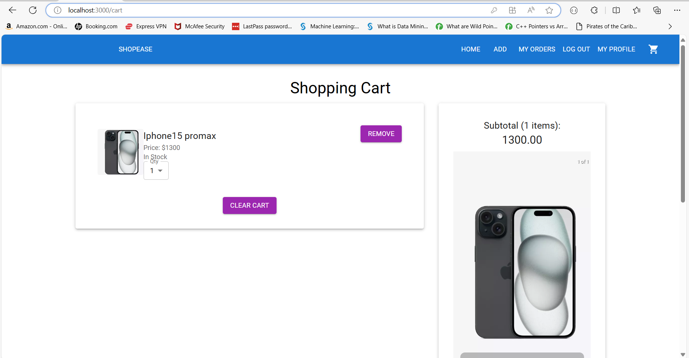

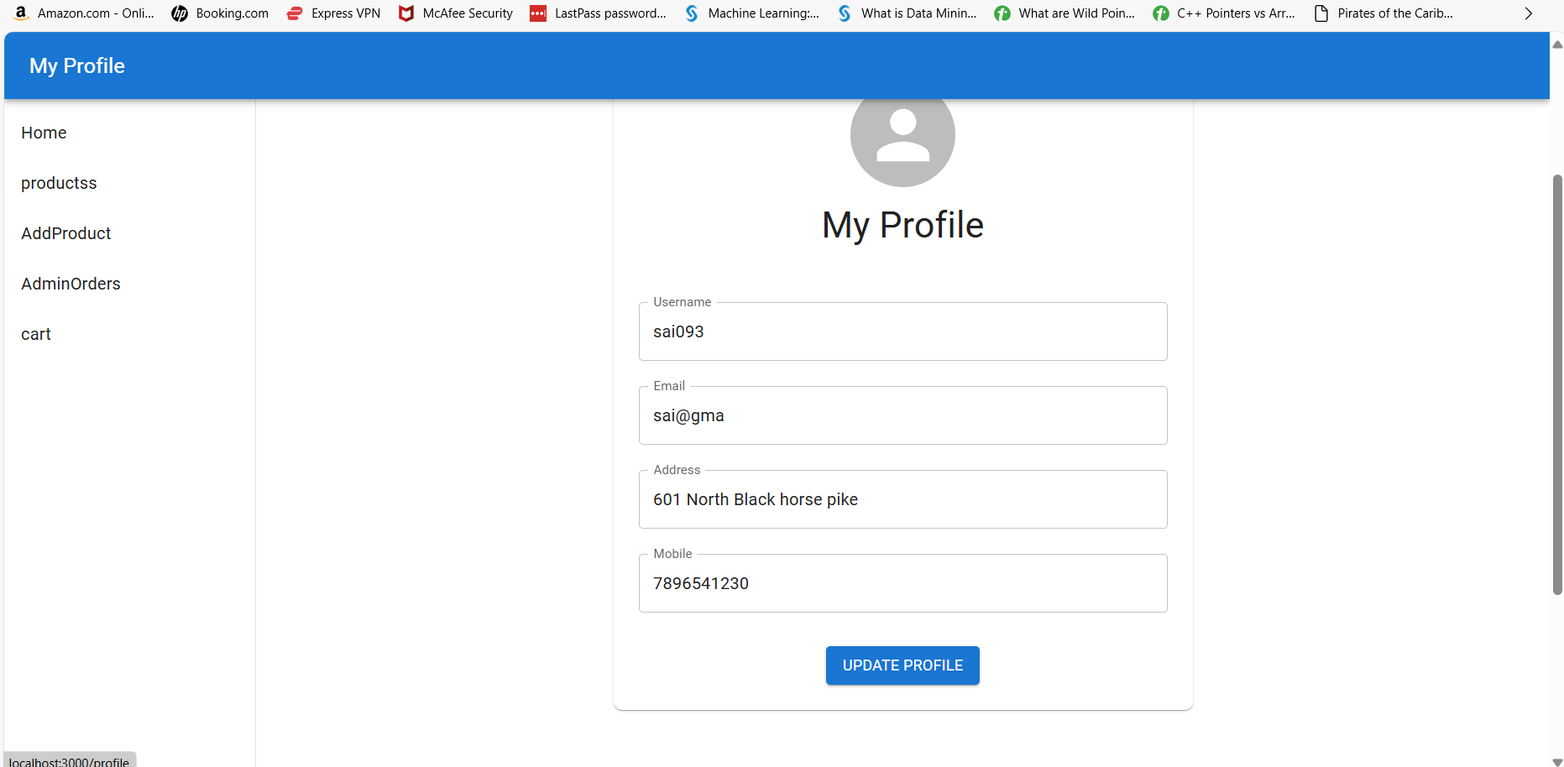

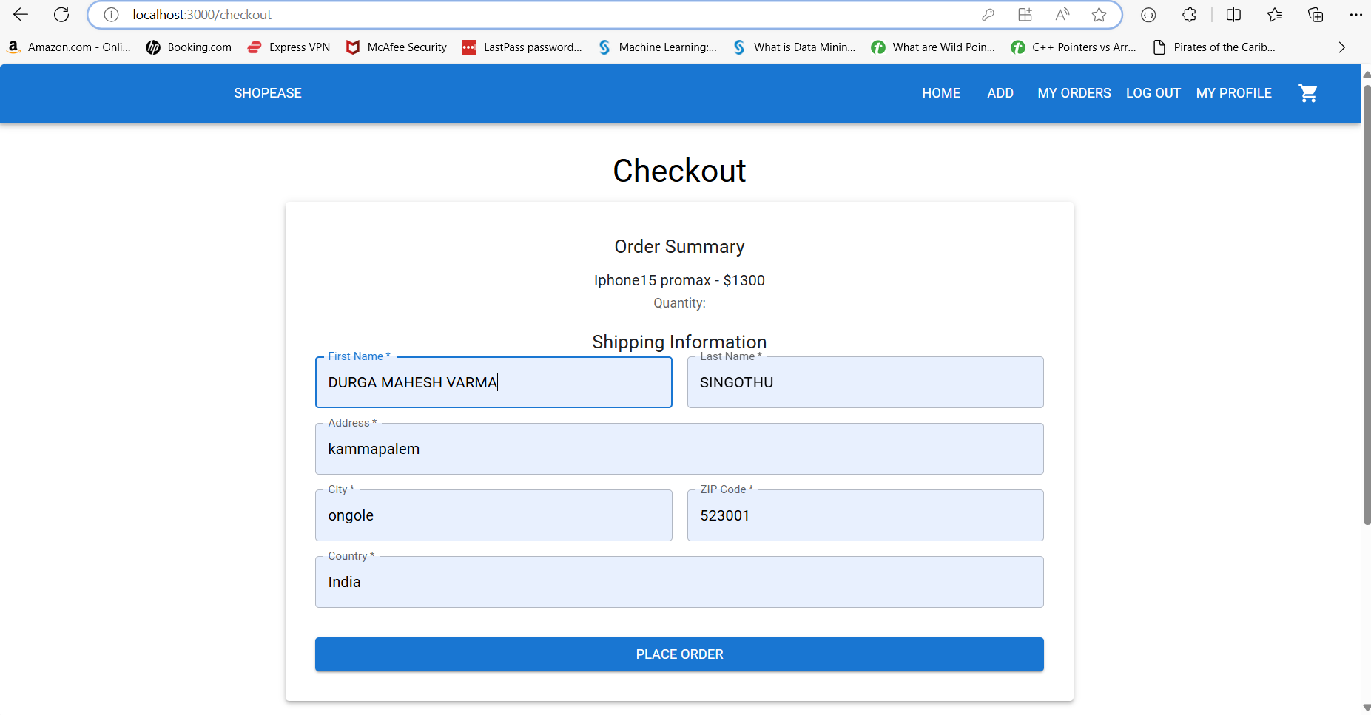

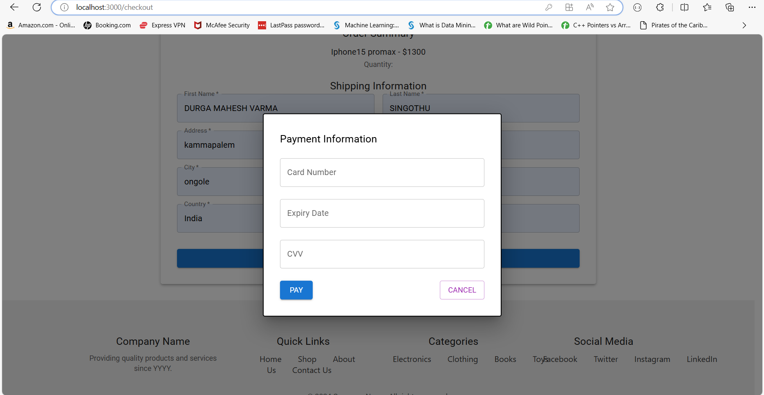

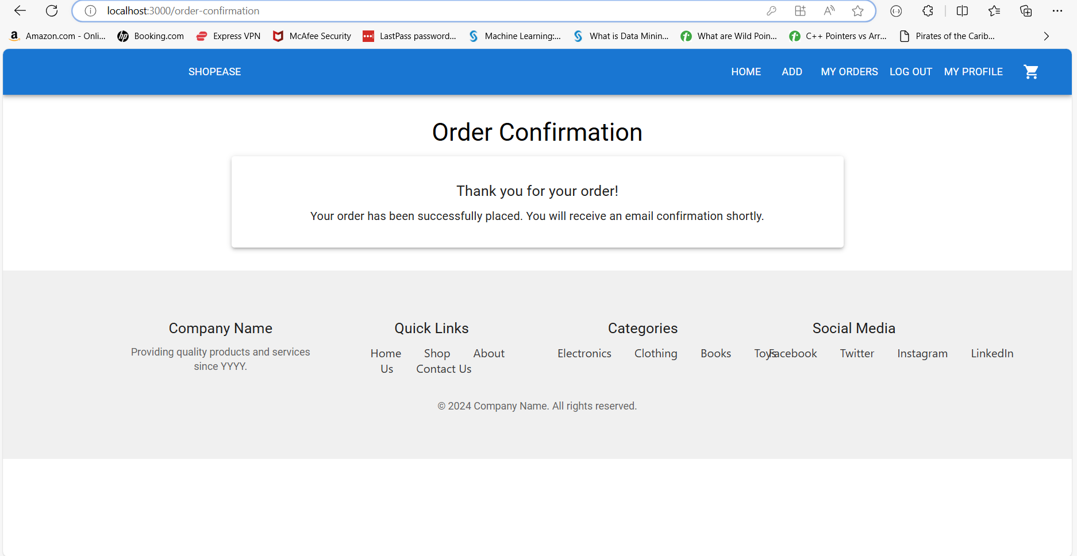

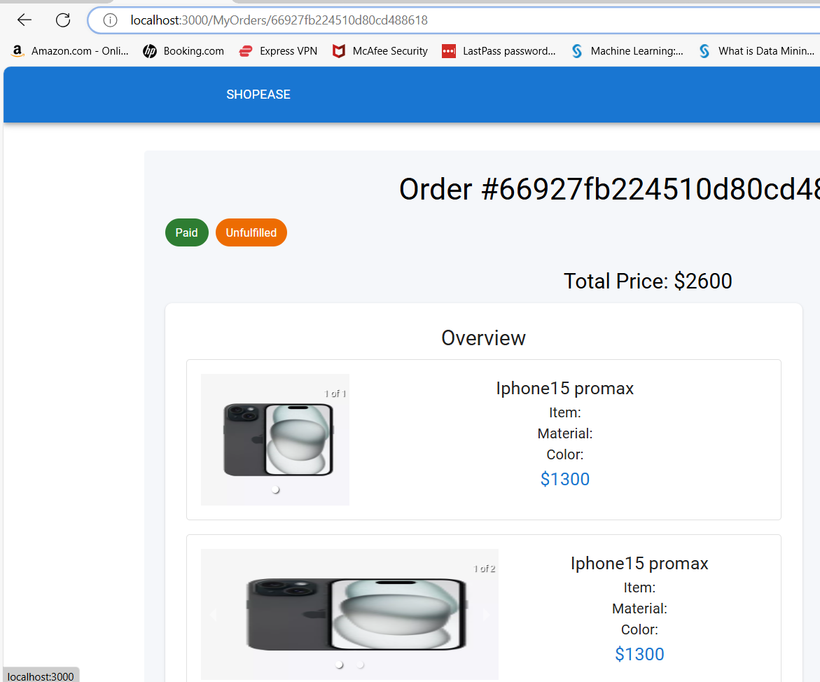

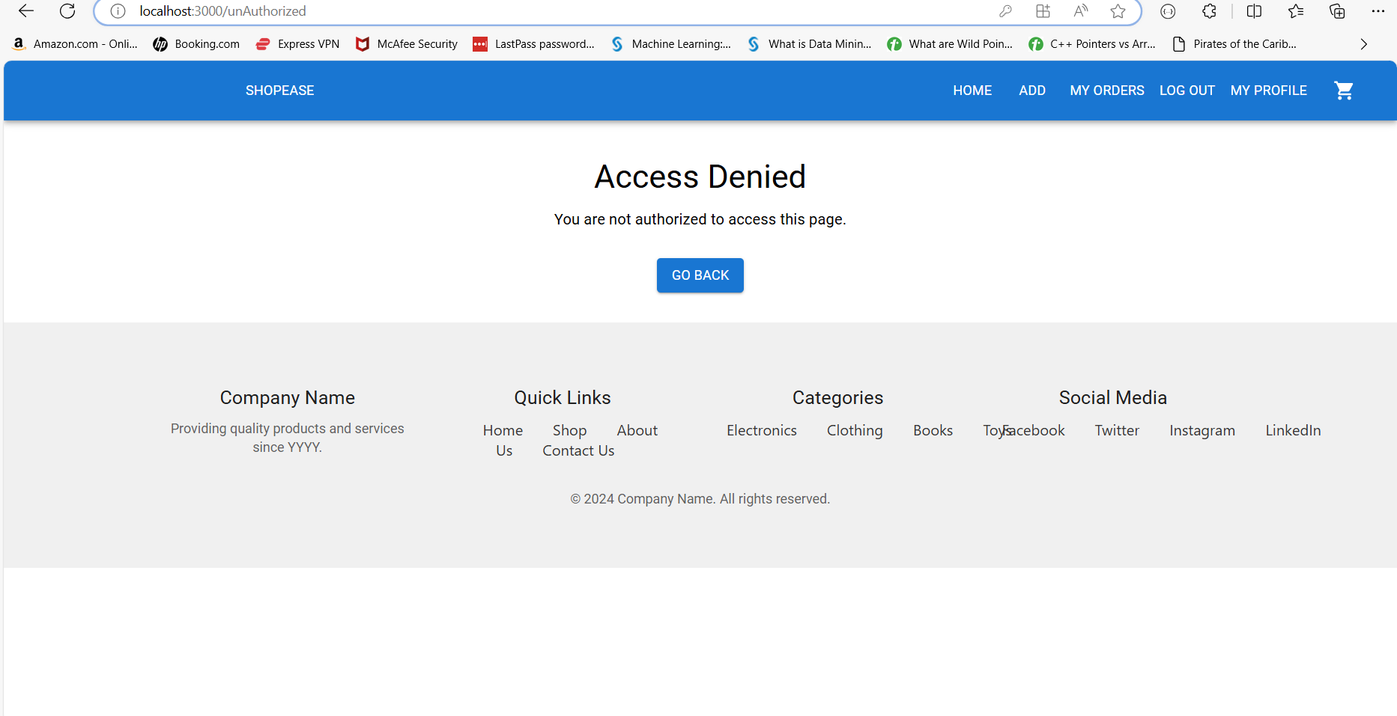

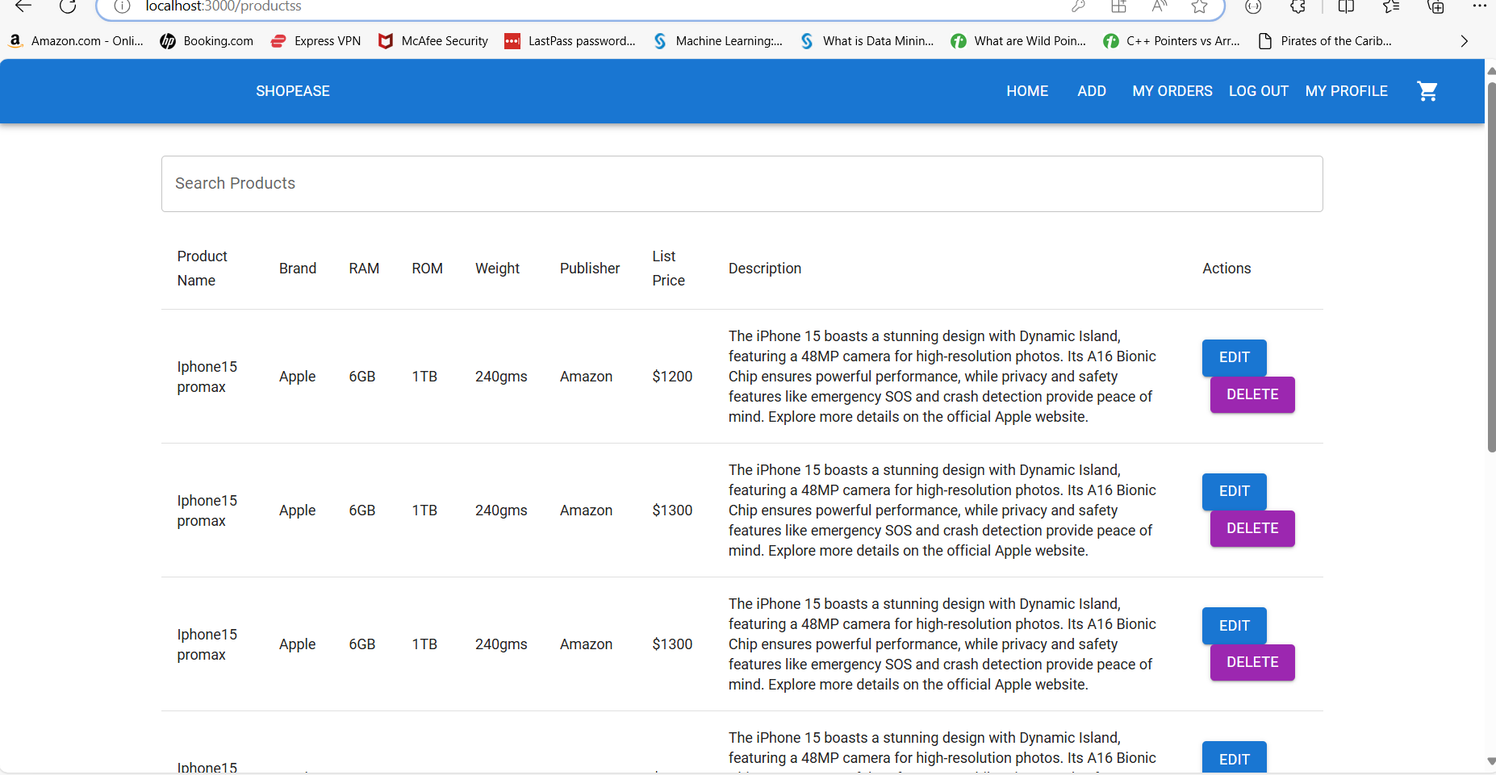

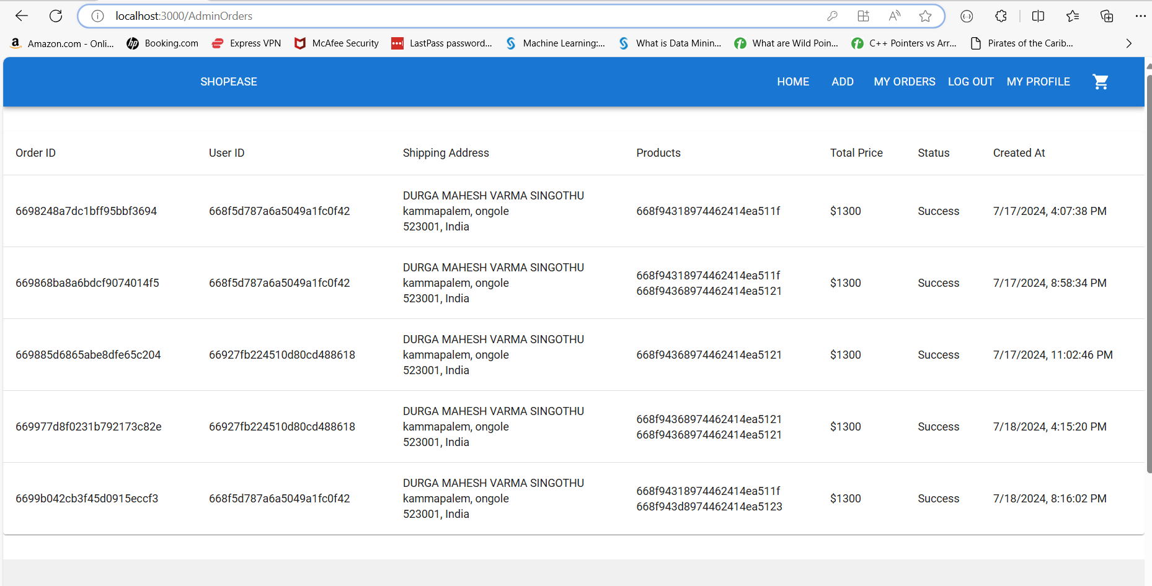

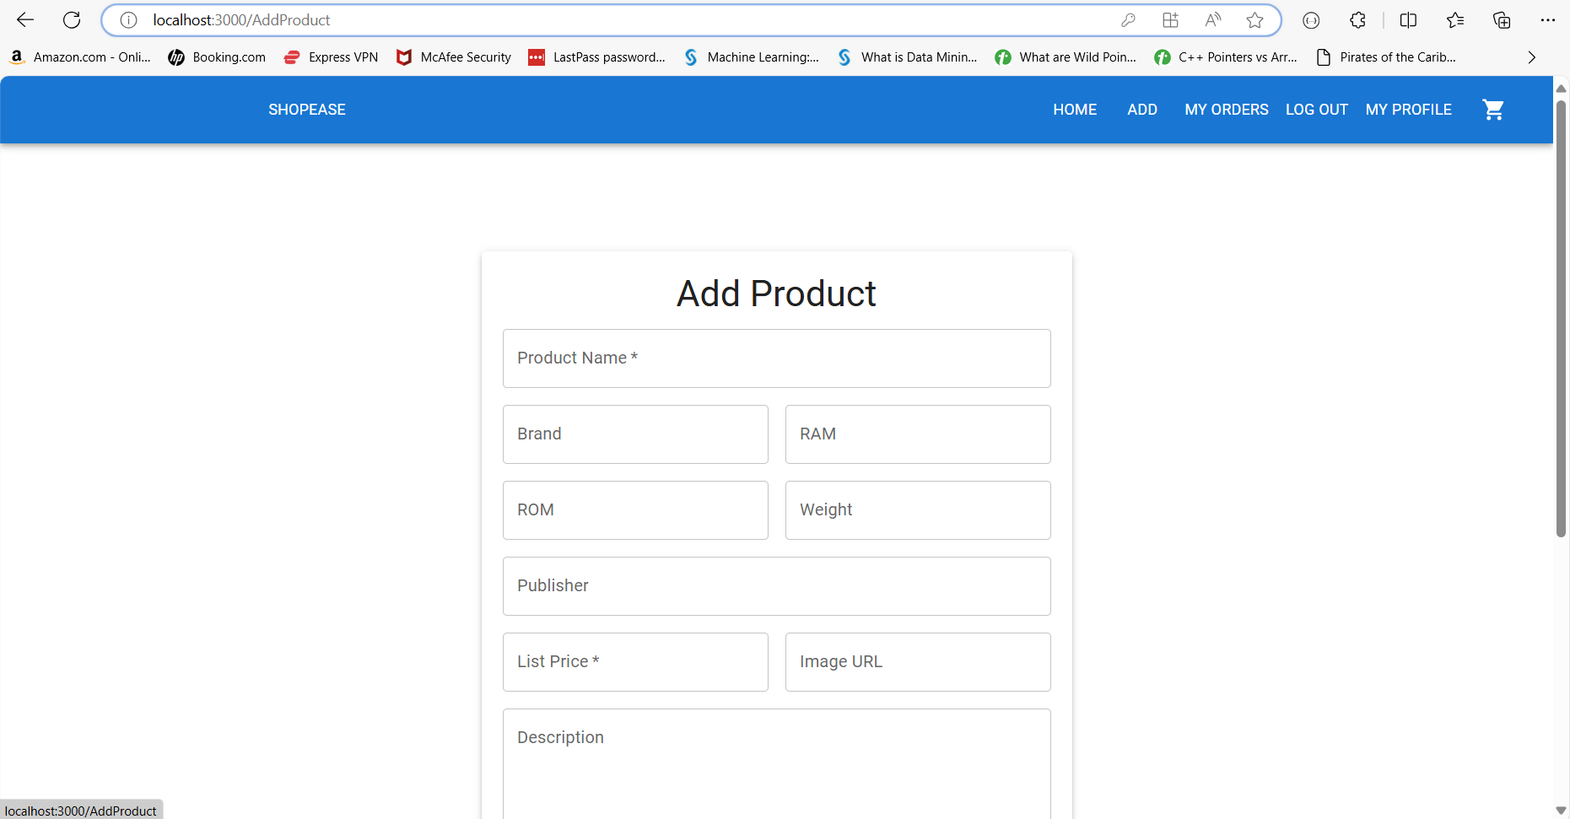

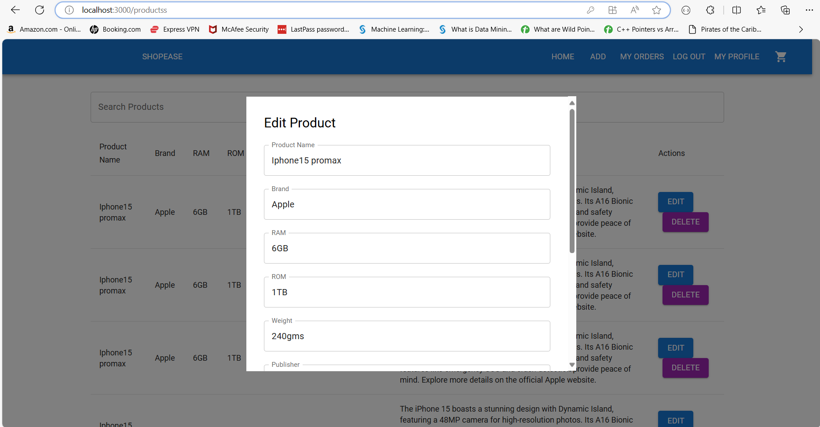

MongoDb

